NEA PROJECT:
CHESS AI

NAME: Magdalena Maciak
Center Number:
Candidate Number:

Analysis:
a clear statement that describes the problem area and the specific problem being solved / investigated
an outline of how the problem was researched
a statement indicating who the problem is being solved / investigated for
background in sufficient detail for a third party to understand the problem being solved / investigated
a numbered list of measurable, "appropriate" specific objectives, covering allrequired functionality of the solution or areas of investigation (‘appropriate’ means thespecific objectives are single purpose and at a level of detail that is without ambiguity)
any modelling of the problem that will inform the Design stage, for example a graph/ network model of Facebook connections or an E-R model, state diagrams, scientific / mathematical models or formulae, data flow diagrams
Background to project:
Evidence of analysis:
Set of Objectives:
- Front end (Visual Design)
  - Menu Form
  - Table Form
  - Save Form
  - Select Form
- Front end (Coding)
  - Decompression/Compression of the Board
  - Open a previous saved game
  - Produce a table of interactable buttons on the board
  - Load pictures for the Chess pieces
  - Algorithm that calculates all the diagonal moves (this will be for Bishop and Queen)
  - Algorithm that calculates all the perpendicular and parallel moves (this will be used for Castle and Queen)
  - Basic Pawn moves
  - Advanced Pawn moves (al pansunt and promotion)
  - Horse moves
  - King moves
  - Dealing with exceptions while checking for the those moves
  - Visually representing where Chess pieces can move
  - Defeated List for Black and White
- Back End (DataBase)
- Back End (AI)

Current System
Language of choice:
Windows forms (C#)
Windows forms gives me the ability to visually represent my chess game that is easier and more dynamic than having to use just C#.Net. It allows more interactivity by registering buttons and inputs of separate text boxes. Which in turn makes it understandable and user friendly. It also separates the front end (the visual) from the back end which increases efficiency since I know where to access subroutines.
It’s a good language, as I have the knowledge and experience with c# but also it is testing me on the additional features (windows forms) that have be treated differently.
This code also gives me the option to use databases, which will be very critical when I design my machine learning algorithm.
Displaying the board visually can benefit my game, because otherwise they would have needed to learn chess notation in order to move pieces around the board. It would have taken the user a longer time to learn that instead of learning to play the game itself. They have given the ability to also highlight the buttons, this can be used to display all the possible moves. This is perfect as I can make the program very beginner friendly.
Identification of end-user
Prospective users
Modelling of problem
Original plan:
I was going to use a pre-existing website in order to play with random people to improve my ai. This would make the process of gathering intel much easier and allow me to gather more data than having only me play against it. Because this will cause the intelligence of my ai to deal with different play styles and not be capped by the way I play. This will also reduce the amount of time taken to get that information.
The way I was going execute this was by first making a picture/word detection algorithm to read the Chess notation. It is much better than trying to read the entire board, as it would take much longer to process all the pictures and information that it would take my ai too long to move a piece.
Then after I got that to work, I would then create an interacting algorithm which will move the mouse on the screen, click and drag to move the pieces. But in order to move them I need to know where the click boxes of the squares are to relation to the webpage. This would be dealt with a mathematical algorithm.
Prototype and critical path of my code

Research of investigation area
Applications that already exist:
Chess.com is a very used website for playing chess
Strongest Chess AI’s
- Stockfish
- AlphaZero
- Komodo
There are many simpler versions on other chess applications and apps on the google play and the apple store

Proposed solution details
AI Plan:

Acceptable limitations (agreed by end-user)
Data volumes
Log/diary of research collection
Diary:
20th September 2020
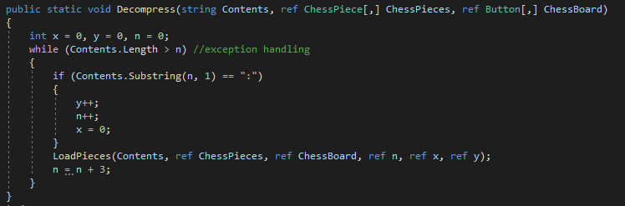
At the start I used c#.Net to code my draft of the game. While coding the display I had a problem decompressing my starting line. It was because I used “=” instead of “==” in my if statement and misusing the substring command. I realised that I need to add a length of the string I wanted to get. If I did not specify a value, it would take everything from x to the end of the string. Which was not useful for my decompression algorithm.

Another major problem I hit was having the “ChessBoard[7,7].Name” to display the decompressed version. A pupil, called Tim, looked through my code and told me I required to create an Abstract Chesspiece class which will inherit all the types of chesspieces. Along with that, I had to create abstract methods to override other classes when a method of “.Name” was called out to get the specific objects information.
Instead of “object[]ChessBoard = new object[7,7]”
I replaced it with “ChessPiece[] ChessPieces = new ChessPiece[7,7]”

29th September:
After a bit of coding and researching, I have decided to use window. Forms to help with displaying and allowing the user to interact with the board. I need to rewrite code in particular parts in order for it to work with the display.
Another problem I have stumbled upon, is that the forms can increase in size but the images and buttons do not.

High level overview
structure / hierarchy chart
a system flowchart
a data flow diagram, or object / class diagrams, accompanied by any further explanation that is helpful
non-standard diagrams that combine elements of data flow and program control floware acceptable, as long as the two can be clearly distinguished
Description of algorithms
Description of data structures
File structure and organisation
Database design
Queries
If a project uses a database, samples of the queries that are used, together with explanations should be provided. The samples chosen should illustrate the sophistication of the system.
Design of user interface
System security and integrity of data
My Completed Solution:
Evaluation:

